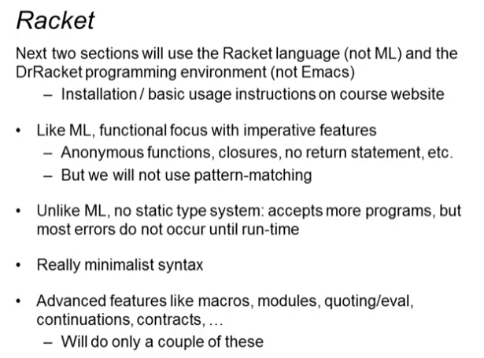

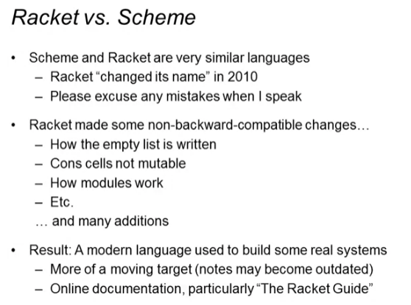

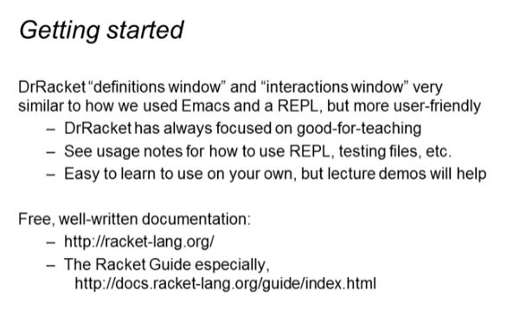

Comments:

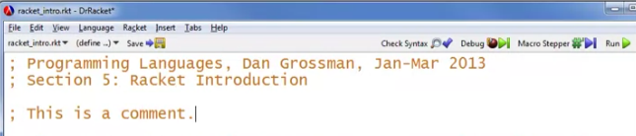

First non-comment must be:



If you want to put your tests on another file:



* Because each file is a module and by default, everything in it is private
* This is necessary so we can make tests in different file and still access the private file of our code
* This is making everything public

Defining variables:

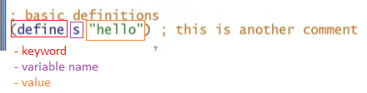

Using the terminal (after clicking the run button)

